Molecular engineering of hole selective layer for high bandgap perovskites for highly efficient and stable perovskite-silicon tandem solar cells
Guoliang Wang,^{1,2†} Jianghui Zheng,^{1,2,3,4†}* Weiyuan Duan,^{5†} Jiong Yang,^{6†} Md Arafat Mahmud,^{1,2} Qing Lian,⁷ Shi Tang,^{1,2} Chwenhaw Liao,^{1,2} Jueming Bing,^{1,2} Jianpeng Yi,^{1,2} Tik Lun Leung,^{1,2} Xin Cui,³ Hongjun Chen,^{1,2} Feng Jiang,⁷ Yulan Huang,⁷ Andreas Lambertz,⁵ Marko Jankovec,⁸ Marko Topič,⁸ Stephen Bremner,³ Yuan-Zhu Zhang,⁶ Chun Cheng,⁷* Kaining Ding,⁵* Anita Ho-Baillie ^{1,2,3,9}*

Affiliations

¹School of Physics, The University of Sydney, Sydney, NSW 2006, Australia
²The University of Sydney Nano Institute (Sydney Nano), The University of Sydney, Sydney, NSW 2006, Australia
³Australian Centre for Advanced Photovoltaics (ACAP), School of Photovoltaic and Renewable Energy Engineering, University of New South Wales, Sydney 2052, Australia
⁴Sustainable Energy Research Centre, School of Engineering, Macquarie University, Sydney, NSW 2109, Australia

⁵IEK-5 Photovoltaics, Forschungszentrum Jülich GmbH, 52428 Jülich, Germany

⁶Department of Chemistry, Southern University of Science and Technology, Shenzhen, Guangdong Province 518055, People’s Republic of China

⁷Department of Material Science and Engineering, Southern University of Science and Technology, Shenzhen, Guangdong Province 518055, People’s Republic of China

⁸Faculty of Electrical Engineering, University of Ljubljana, Tržaška 25, Ljubljana, 1000 Slovenia

⁹Lead Contact

†These authors contribute equally to this work.

*Corresponding author:

Email: anita.ho-baillie@sydney.edu.au (A.H.), k.ding@fz-juelich.de (D.K.), chengc@sustech.edu.cn (C.C.), jianghui.zheng@sydney.edu.au (J. Z.)

SUMMARY

In this work, a novel carbazole-based SAM (Ph-2PACz) was developed for facilitating efficient hole extraction and suppressing carrier recombination in high bandgap (1.67 eV) perovskites for single junction and tandem cell demonstrations. The champion 21.3% efficient 1.67 eV cell produced high fill factor (FF) of 82.6% and open-circuit voltage (V_{OC}) of 1.26V representing low bandgap-voltage offset at 0.41 V. When Ph-2PACz was applied to the top perovskite cell for a monolithic perovskite-Si tandem, a PCE of 28.9% (on 1cm²) and a V_{OC} of 1.91V was obtained. When encapsulated, a tandem cell demonstrated excellent stability under continuous 1 sun illumination (680h) and Damp-Heat (280 h at 85°C + 85% relative humidity) and passed the International Electrotechnical Commission (IEC) 61215 61215 Thermal Cycling (200 cycles between -40°C and 85°C) test retaining 98.8% of initial PCE.

Key words: self-assembled monolayer (SAM), hole-selective contact, perovskite-silicon tandem, International Electrotechnical Commission (IEC) stability test.

INTRODUCTION
Hybrid organic-inorganic metal halide perovskite solar cells (PSCs) have attracted immense research interest in recent years¹. They have experienced the most rapid rate of efficiency improvement amongst all photovoltaic technologies due to their excellent absorption co-efficient,² defect-tolerance,³ good carrier lifetime and diffusion length,⁴ and ease of fabrication.^{5,6} Recently, the certified power conversion efficiency (PCE) of the best PSC has reached 26.1%⁷ approaching the theoretical limit for single-junction solar cells at 33.8%,⁸ leaving small headroom for improvements. To surpass this efficiency limit of single junction cells, integrating a high bandgap perovskite with a suitably low bandgap photovoltaic material, such as crystalline silicon (c-Si), copper indium gallium diselenide (CIGS), organic photovoltaics (OPV), or perovskites has been proven to be an effective and promising method mitigating thermalization and sub-bandgap-absorption losses. Such double-junction solar cell concept has a higher theoretical limit at 45%.⁸ Among various double-junction perovskite tandem technologies, perovskite-Si tandem is one of the most promising and most researched approach as the certified PCE of the best device has recently reached 33.7%.⁷
High bandgap PSC (~ 1.67eV) is a suitable top cell for high performance perovskite-silicon tandems to achieve output current matching.^{9,10} However, these high-bandgap PSCs suffer from higher bandgap-voltage offset, W_{OC} (= Eth/q – V_{OC} where Eth is the absorption edge, loosely defined as “bandgap”, and q is elementary charge) compared to mid-bandgap (e.g. 1.5eV) PSCs.¹¹ The large W_{OC} in high bandgap PSCs can be attributed to phase segregation,^{12,13} non-radiative recombination,¹⁴ and energetic misalignment between the perovskite and charge selective layers.^{15,16} For the first two issues, pure-iodide perovskites¹⁷ and passivations¹⁸ have been developed to supress phase segregation and non-radiative recombination, respectively.¹⁹⁻²² In terms of electron selective material, indence-C60 bisadduct (ICBA), with shallow energy level has been utilized in high bandgap PSCs to minimize W_{OC}.²³ In terms of hole selective material, the most commonly used ones based on poly[bis(4-phenyl) (2,4,6-trime-thylphenyl) amine] (PTAA), poly[N,N'-bis(4-butylphenyl)-N,N'-bis(phenyl)-benzi (Poly-TPD), poly(3,4-ethylendioxythiphene):poly (styrenesulfonate) (PEDOT:PSS) and NiO_{X} suffer from energy band misalignment with high bandgap perovskites, thus resulting in severe W_{OC}.^{16,24-27} To overcome this, self-assembled monolayers (SAM’s) have emerged as effective hole selective layers (HSL) ²⁸⁻³⁰. SAM typically consists of an anchoring group; a spacer; and a terminal group. The choices available for these groups allow for a large design space for functionalities. SAM-HSL’s also have other advantages such as low material consumption, better wettability, and defect passivation.^{15,16} Typical terminal groups that have recently been used for high performance perovskite cell demonstrations include carbazole³¹, phenothiazine,³² and spiro-acid³³ (spiro = spirobifluorence). Additional interfacial material properties can also be achieved by using different anchoring groups.³⁴ Carbazole-based SAM-HSL’s have emerged due to their respectable stability,³⁵ energy level alignment with perovskites^{15,16} and they are “electron rich” favouring hole-selectivity.³¹ One of the earlier reports involved the use of (2-{3,6-bis[bis(4-methoxyphenyl)amino]-9H-carbazol-9-yl}ethyl)phosphonic acid (V1036) and butylphosphonic acid (C4) as a hole selective contact in p-i-n PSCs producing a PCE of 17.8%.³⁶ Following that, newer SAM-HSL’s, including [2-(9H-carbazol-9-yl) ethyl] phosphonic acid (2PACz), [2-(3,6-Dimethoxy-9H-carbazol-9-yl) ethyl] phosphonic acid (MeO-2PAcz) and 4-(3,6-dimethylcarbazol-9-yl) butyl phosphonic acid (Me-4PACz) were developed to achieve better energy alignment (e.g., favouring cascaded charge transfer^{37,38}) with perovskite or for fast hole extraction for high bandgap PSCs and thus greatly enhancing their performance, typically their V_{OC} and fill factor (FF).^{15,16,32,39}The molecular structures in the terminal group used in these report can limit charge transfer due to the lower density of delocalization electrons. Additionally, it is also challenging to obtain a full coverage of perovskite on some of these SAMs.^{16,40} Therefore, rational design of SAM-HSL is highly desired to improve charge transport along with suppressing non-radiative recombination. This can be achieved by an extended conjugated system, ^{40,41} allowing for delocalization of electron which can also lead to an energetic stabilization of the molecules, thus improving material stability.²⁹ Therefore, in this work, we develop a new carbazole SAM-HSL based on (2-(3,6-diphenyl-9H-carbazol-9-yl) ethyl) phosphonic acid (Ph-2PACz) by introducing two benzene rings to create an extended conjugated system. The contorted structure of the carbazole derivant (3,6-Diphenyl-9H-carbazole) in the Ph-2PACz weakens π-π intermolecular interaction thereby favouring self-assembly.⁴² As a result, a PCE of 21.3% with a V_{OC} of 1.26 V and a FF of 82.6% was achieved by the champion 1.67eV p-i-n ITO/Ph-2PACz/Cs_{0.15}FA_{0.65}MA_{0.2}Pb(I_{0.8}Br_{0.2})₃/LiF/C₆₀/BCP/Cu PSC. These values are higher than the 1.68 eV PSC based on Me-4PACz SAM-HSL previously reported. ¹⁶ We further demonstrated monolithic perovskite-Si tandem solar cells using the novel Ph-2PACz. The champion device produced a PCE of 28.9% with a V_{OC} of 1.91V which is one of the highest values amongst demonstrated perovskite-Si tandems. In addition, the encapsulated Ph-2PACz tandem device showed improved light, thermal and moisture stability when compared with their PTAA and 2PACz based counterparts. Notably, the encapsulated Ph-2PACz based perovskite-Si tandem device passed the IEC 61215 2021 Thermal Cycling test (-40 ℃ <->85 ℃) retaining 98.8% of its initial PCE after 200 cycles.

RESULTS AND DISCUSSION

In this work, three different hole selective layers were employed for 1.67 eV p-i-n PSCs. They were the widely used PTAA, commercially available SAM 2PACz,⁴³ and newly developed and synthesised SAM Ph-2PACz. Their respective molecular structures are shown in Figure 1a. Compared with 2PACz, benzene rings were introduced into the Ph-2PACz to the opposite ends of the carbazole moiety. Details of the Ph-2PACz including synthetic pathways (Figure S1), nuclear magnetic resonance spectra (Figures S2-S4), differential scanning calorimetry (DSC) (Figure S5), and thermalgravimetric (TGA) analysis (Figure S6) can be found in the Supplementary Information. The electrostatic surface potentials (ESPs) ⁴⁴ of the three HSLs in Figure 1b show that carbazole of Ph-2PACz has lower charge density than that of 2PACz. This delocalization effect due the presence of the extra benzene rings in Ph-2PACz,⁴⁵ is beneficial for charge transfer and collection.⁴⁶
To further investigate their intermolecular π-π interaction, the single-crystal structures of 9H-carbazole (2PACz) and 3,6-Diphenyl-9H-carbazole obtained from CCDC database,⁴⁷⁻⁴⁹ are shown in Figure S7. 3,6-Diphenyl-9H-carbazole with a twisted structure exhibits a slightly larger intermolecular distance, weakening the π-π interaction and the associated undesirable aggregation,⁵⁰ favouring self-assembly resulting in more uniform surface potential (Figure S8).
The conductivities of the HSL were also determined (Figure S9). Ph-2PACz was 16 to 18% more conductive than PTAA or 2PACz.
Ultra-violet photoelectron spectroscopy (UPS) and absorption measurement were performed on the HSL’s and the perovskite absorber to determine their fermi levels and their highest occupied molecular orbital (HOMO) for the HSL’s or valance band maximum (VBM) for the perovskite. Results are shown in Figure S10. Furthermore, absorption measurements were performed on the HSL’s to determine their optical bandgaps (Figures S11). It is important to note that while similar values to previously reported ones^{15,16} can be obtained when measuring the HSL’s in liquid phases (Figures S11b), a common practice in these reports,^{15,16} we use values obtained from solid phase (Figures S11a) (albeit higher) HSL’s, a more realistic case for solar cells. To determine the absorption threshold of the perovskite absorber, differential of the EQE was calculated (Figure S12).⁵¹ These values were then used to determine the lowest unoccupied molecular orbital (LUMO) levels of the solid HSLs or the CBM (conduction band minimum) for the perovskite. The energy levels are summarized in Figure 1c.
As expected, all HSLs used are p-type. The HOMO levels of PTAA and 2PACz are similar to those previously reported.^{15,16} The LUMO values obtained here are different from those in previously reported ones^{15,16} whereby bandgaps of HSL’s in liquid phases were used to help determine the LUMO levels. Again, we use bandgaps of solid HSL’s, for determining LUMO values, a more realistic case for solar cells. The perovskite is more n-type than expected due to the presence of PEAI^{52,53} (see details under Device Fabrication and Figures S10 d & e in the Supporting Information).
The HOMO levels of the SAM-HSL’s were also calculated using density functional theory (DFT). Results shown in Figure S13 show similar trends to experimental determined ones (values with respect to E_{vac} listed in caption of Figure 1). In terms of band-offsets between the HSL HOMO and the perovskite VBM, they are the lowest for PTAA and Ph-2PACz (Figure 1c). Reason for better than expected^{15,16} performance of PTAA compared to 2PACz is the post-PTAA-deposition DMF treatment used (see details under Device Fabrication in the Supporting Information) that improved the wettability for the perovskite film on the PTAA⁵⁴. This therefore improves the associated interface for better charge extraction which will be reflected in results in Figures 3 g & h when comparing PTAA with 2PACz cells. Nevertheless, the effectiveness of introducing benzene rings for lowering band-offset can be seen when comparing Ph-2PACz with 2PACz (Figure 1c). Added advantage of SAM-HSLs is shown in their UV-vis absorption spectra (Figure 1d) with reduced absorption in the UV region compared with PTAA, thereby reducing optical losses in the complete solar devices.
To investigate the surface properties of SAMs, high-resolution X-ray photoelectron spectroscopy (HR-XPS) was performed. Results in Figure 2 show the XPS spectra for C 1s, N 1s, P 2p, and O 1s for 2PACz and Ph-2PAcz deposited onto ITO substrates. The two SAMs display similar characterization peaks indicative of similar molecular structure. However, for Ph-2PACz compared to 2PACz, we can observe shifting of the N 1s peak towards lower binding energies and P 2p and O 1s peak shifts towards higher binding energies indicative of changes in charge distribution.⁵⁵ To verify this, we calculated Mulliken charge of the molecular atoms of 2PACz and Ph-2PACz. Results listed in Table S1 show that the N atom in Ph-2PACz is more negative while the P and O atoms are more positive compared to 2PACz. The findings are in good agreement with the XPS results.
Contacting angle measurement of the three HSLs was also performed to evaluate the wettability of HSLs for subsequent perovskite film deposition. Results (Figure S14) show a dramatic reduction in contact angle for the 2PACz and Ph-2PACz films – reduced from 84.6° for PTAA to 40.7°and 38.7°, for 2PACz and Ph-2PACz, respectively. This is desirable for better perovskite coverage in subsequent fabrication step as confirmed by cross-section scanning electron microscopy (SEM) images of the perovskite films deposited on the three HSLs. Results in Figure S15 show more uniform perovskite films with larger grains when deposited on 2PACz or Ph-2PACz compared with the film on PTAA. X-ray diffraction (XRD) results in Figure S16 revealed smaller amount of residual PbI₂ in the perovskite film deposited on Ph-2PACz.
Encouraged by the improved perovskite film quality deposited onto Ph-2PACz, we further fabricated 1.67eV p-i-n PSC device with a structure of ITO/HSL/Cs_{0.15}FA_{0.65}MA_{0.2}Pb(I_{0.8}Br_{0.2})₃/LiF/C₆₀/BCP/Cu (Figure 3a) to study the influence of the different HSLs on device performance. Distribution of electrical characteristics of multiple devices of each type are shown in Figures 3d-i while Figure 3b and Table 1 summarises the light J-V characteristics of the champion devices. Ph-2PACz-based devices produced ~3% absolute efficiency enhancement compared with PTAA-based and 2PACz-based devices. This is due to improved V_{OC} (8% and 5% relative improvements compared with PTAA and 2PACz devices, respectively) and FF (9% and 13% relative enhancements compared with PTAA and 2PACz devices, respectively). The latter is due to significant reduction in series resistance (R_{S}) in Ph-2PACz-based devices (Figure 3h). The elimination of UV parasitic absorption (otherwise present in the PTAA-based devices) in the 2PACz and Ph-2PACz devices also contribute to improved J_{SC} and therefore device performance. Impressively, the 21.3% champion cell produced a V_{OC} of 1.26V and a FF of 82.6%, which are the highest for any 1.67 eV bandgap PSCs to-date (Table S2 and Figure S17).⁵⁶ The bandgap-voltage offset at 0.41 V is one of the lowest for any >1.67 eV PSCs with a record efficiency (Figure S18).

To gain insights into the underlying mechanism of enhanced device performance with Ph-2PACz, various characterisations on perovskite films deposited on PTAA, 2PACz and Ph-2PACz (Figure 4a) and on actual PSCs with PTAA, 2PACz and Ph-2PACz as hole selective layers (Figures 4b-f) were performed.
Steady-state photoluminescence (PL) (Figure S19) and time-resolved photoluminescence (TRPL) (Figure 4a & Table S3) measurement results show that perovskite film on Ph-2PACz produces the highest PL intensity and longest carrier lifetime compared to those on PTAA and 2PACz, indicating reduced carrier non-radiative recombination.⁵⁷ These correlate with the trend in V_{OC} of the and built-in potential (V_{bi}), determined by Mott-Schottky analysis (Figure 4b) of associated devices 0.96 V for Ph-2PACz devices, 0.93V for 2PACz devices, and only 0.7V for PTAA devices. From light-intensity dependent V_{OC} measurements (Figure 4c), the ideality factor of the Ph-2PACz device determined was lower at 1.31 compared to 1.44 for the 2PACz device and 1.45 for the PTAA device, indicating effective suppression of trap-assisted Shockley–Read–Hall (SRH) recombination in the Ph-2PACz device.¹⁹ This is confirmed by results of thermal admittance spectroscopy (TAS) (Figure 4d) providing evidence for deeper trap (“Band Ⅱ” in Figure 4c) suppression. These deeper traps are related to the perovskite/HSL interface. This is because E_{a} calculated from temperature-dependent V_{OC} measurements (Figure 4e) increased from 1.57, to 1.69 and 1.72 eV as HSL was changed from PTAA, 2PACz to Ph-2PACz, respectively suggesting recombination became more bulk dominated as the perovskite/HSL interface improved by switching towards SAM type HSL with Ph-2PACz being the best performer.⁵⁸
In addition, it was found that carrier extractions also improved when the Ph-2PACz HSL was used in the devices according to the results of transient photocurrent measurements (Figure 4f).
It is clear that a better HSL/perovskite interface is formed when Ph-2PACz is the HSL due to a stronger intermolecular interaction between Ph-2PACz and the perovskite film evidenced by the Pb 4f peaks shift towards higher binding energies in the XPS spectra (Figure S20). Not only does this contribute to enhanced performance, previous studies^{25,26} also reported enhanced stability of associated solar devices due to a stronger interaction between the HSL and the perovskite. This is also observed in our tandem device with improved stability which will be discussed in the following.
Inspired by the substantial enhancement in single-junction device using Ph-2PACz, we further demonstrated monolithic perovskite-silicon tandems (Figures 5a and 5b) comparing their performance using PTAA, 2PACz and Ph-2PACz HSLs. Details of tandem device fabrication can be found in the Supplementary Information. Again, tandems using the Ph-2PACz HSL performs the best (Figure 5c and Table 2). The champion cell produced a reverse scan PCE of 28.9% on 1.03 cm² with a V_{OC} of 1.91 V, with negligible hysteresis (Figure S21), and a steady-state efficiency of 29.0% (Figure S22). The PTAA and 2PACz based tandem devices achieved a PCE of only 26.0% and 26.2%, and a steady-state efficiency of 25.9% and 26.2% (Figure S23) respectively. From the EQE spectra of the Ph-2PACz based tandem (Figure 5d), it is clear that the top perovskite cell is limiting the current output of the tandem which will be addressed in future work such as increasing the thickness of the perovskite layer beyond 600 nm, as currently observed in the cross-section scanning electron microscopy (SEM) image (Figure 5b).
Finally, we evaluate the durability of the encapsulated tandem devices by performing IEC Damp-Heat test, IEC Thermal Cycling test and maximum power point tracking. Results (Figure 6) show that Ph-2PACz-based tandem devices were most durable compared to the PTAA and 2PACz tandems. The Ph-2PACz based tandem device showed enhanced damp-heat durability (85℃, 85% RH), producing negligible performance losses after 280 hours of damp heat. Notably, the encapsulated Ph-2PACz based tandem device retained 98.8% of its initial PCE after 200 thermal cycles passing the IEC 61215 photovoltaic module standard. The Ph-2PACz based tandem device was also stable during 680 hours of continuous 1 Sun illumination. The enhanced durability of the Ph-2PACz-based tandem device is attributed to both better perovskite film quality (with less residual PbI₂ as shown in Figure S16 and discussed above) and better perovskite/HSL interface (due to better perovskite-HSL interaction as shown in Figure S20 and discussed above) suppressing potential sites or pathways for degradation.

Conclusions
In summary, we have developed a new carbazole-based self-assembled monolayer type hole selective layer - Ph-2PACz for high bandgap perovskite solar cells which is also suitable for multi-junction perovskite-based tandems. The new SAM HSL exhibits lower band-offset between its HOMO level and the perovskite VBM, better surface wettability facilitating better perovskite film formation, better perovskite/HSL interface, and faster charge extraction. As a result, enhanced V_{OC} of 1.26 V and FF of 82.6% can be produced by a 21.3% efficient 1.67eV p-i-n single junction PSC. These are the highest values for any 1.67eV PSCs to-date. When the Ph-2PACz HSL was used in a monolithic perovskite-silicon tandem, a PCE 28.9% and a high V_{OC} of 1.91 V were achieved with by the champion tandem which was also more stable than tandems that used PTAA and 2PACz-as their HSLs. Notably, an encapsulated Ph-2PACz-based perovskite-silicon tandem passed the IEC 61215 standard Thermal Cycling test, which was one of the few that passed the Thermal Cycling tests.^{59,60} This work demonstrates an effective strategy of designing self-assembled monolayer type hole selective layer for high bandgap perovskites, improving their voltage outputs, critical for many high performance and durable multi-junction perovskite-based tandems.
EXPERIMENTAL PROCEDURES
Resource availability
Lead contact
Further information should be directed to the lead contact, Anita Ho-Baillie (anita.ho-baillie@sydney.edu.au).
Material availability
All the experimental procedures of the material synthesis are provided in the supplemental information.
Data and code availability
All data needed to evaluate the conclusions in the paper are present in the paper or the supplementary materials.
All the data are available from the corresponding authors upon reasonable request.

SUPPLEMENTAL INFORMATION

Supplemental information can be found online at:

ACKNOWLEDGMENTS
This work is supported by the Australian Government through the Australian Renewable Energy Agency (ARENA) via projects 2020 RND001, 2020 RND003, and 2022 TRAC007 and the Australian Research Council (ARC) via Future Fellowships FT210100210 for A H.-B.. G. W. acknowledge the support of University of Sydney International Stipend Scholarship (USydIS). S. T., C. L. and J. Y. acknowledge the support of the John Hooke Chair of Nanoscience Postgraduate Research Scholarships. T. L. L is supported by the University of Sydney Faculty of Science Postgraduate Research Excellence Award. The authors acknowledge the technical and scientific assistance provided by the facilities as well as the scientific and technical assistance of the Research & Prototype Foundry Core Research Facility at the University of Sydney, part of the Australian National Fabrication Facility and Electron Microscopy Unit at UNSW. M. J. and M.T acknowledge the support of Slovenian Research Agency (Javna agencija za raziskovalno dejavnost Republike Slovenije, ARRS) under the research program P2-0415.

AUTHOR CONTRIBUTIONS
G. W., J. Z. and A. H-B. conceived the project. G. W. and J. Y. synthesized the new SAM. G. W. fabricated the single junction device. G. W and J. Z. fabricated the tandem devices. W.D., A.L. and K.D. fabricated the Si bottom cells. G. W. and J. Z. performed cell measurements. G.W., J.Z., M.A.M., Q.L., S.T., C. L., J.B., X. C., T. L. L., and F.J. conducted film characterizations. J. B. assisted with tandem stability testing. G.W., J.Z., M.A.M., and A. H-B wrote the manuscript. All authors contributed to result discussions. A. H-B. and J. Z. supervised the work.

DECLARATION OF INTERESTS
A. Ho-Baillie is a founder of EurokaPower Pty Ltd and a member of its scientific advisory board.
ReferenceS
1. Green, M.A., Ho-Baillie, A., and Snaith, H.J. (2014). The emergence of perovskite solar cells. Nature Photonics 8, 506-514. 10.1038/nphoton.2014.134.
2. Dhanabal, R., and Dey, S.R. (2022). Perovskite solar cells: recent progress and strategies developed for minimizing interfacial recombination. Frontiers of Materials Science 16, 220595. 10.1007/s11706-022-0595-7.
3. Park, N.-G. (2020). High Efficiency Perovskite Solar Cells: Materials and Devices Engineering. Transactions on Electrical and Electronic Materials 21, 1-15. 10.1007/s42341-019-00156-0.
4. Zhao, Y., Nardes, A.M., and Zhu, K. (2014). Solid-State Mesostructured Perovskite CH3NH3PbI3 Solar Cells: Charge Transport, Recombination, and Diffusion Length. The Journal of Physical Chemistry Letters 5, 490-494. 10.1021/jz500003v.
5. Zuo, C., Bolink, H.J., Han, H., Huang, J., Cahen, D., and Ding, L. (2016). Advances in Perovskite Solar Cells. Advanced Science 3, 1500324. https://doi.org/10.1002/advs.201500324.
6. Green, M.A., and Ho-Baillie, A. (2017). Perovskite Solar Cells: The Birth of a New Era in Photovoltaics. ACS Energy Letters 2, 822-830. 10.1021/acsenergylett.7b00137.
7. NREL. https://www.nrel.gov/pv/cell-efficiency.html. (Accessed 31th Augest 2023).
8. Ho-Baillie, A.W.Y., Zheng, J., Mahmud, M.A., Ma, F.-J., McKenzie, D.R., and Green, M.A. (2021). Recent progress and future prospects of perovskite tandem solar cells. Applied Physics Reviews 8, 041307. 10.1063/5.0061483.
9. Bremner, S.P., Yi, C., Almansouri, I., Ho-Baillie, A., and Green, M.A. (2016). Optimum band gap combinations to make best use of new photovoltaic materials. Solar Energy 135, 750-757. https://doi.org/10.1016/j.solener.2016.06.042.
10. Aydin, E., Allen, T.G., De Bastiani, M., Xu, L., Ávila, J., Salvador, M., Van Kerschaver, E., and De Wolf, S. (2020). Interplay between temperature and bandgap energies on the outdoor performance of perovskite/silicon tandem solar cells. Nature Energy 5, 851-859. 10.1038/s41560-020-00687-4.
11. Almora, O., Baran, D., Bazan, G.C., Berger, C., Cabrera, C.I., Catchpole, K.R., Erten-Ela, S., Guo, F., Hauch, J., Ho-Baillie, A.W.Y., et al. (2021). Device Performance of Emerging Photovoltaic Materials (Version 2). Advanced Energy Materials 11, 2102526. https://doi.org/10.1002/aenm.202102526.
12. Yang, T.C.-J., Fiala, P., Jeangros, Q., and Ballif, C. (2018). High-Bandgap Perovskite Materials for Multijunction Solar Cells. Joule 2, 1421-1436. https://doi.org/10.1016/j.joule.2018.05.008.
13. Hoke, E.T., Slotcavage, D.J., Dohner, E.R., Bowring, A.R., Karunadasa, H.I., and McGehee, M.D. (2015). Reversible photo-induced trap formation in mixed-halide hybrid perovskites for photovoltaics. Chemical Science 6, 613-617. 10.1039/C4SC03141E.
14. Mahesh, S., Ball, J.M., Oliver, R.D.J., McMeekin, D.P., Nayak, P.K., Johnston, M.B., and Snaith, H.J. (2020). Revealing the origin of voltage loss in mixed-halide perovskite solar cells. Energy & Environmental Science 13, 258-267. 10.1039/C9EE02162K.
15. Al-Ashouri, A., Magomedov, A., Roß, M., Jošt, M., Talaikis, M., Chistiakova, G., Bertram, T., Márquez, J.A., Köhnen, E., Kasparavičius, E., et al. (2019). Conformal monolayer contacts with lossless interfaces for perovskite single junction and monolithic tandem solar cells. Energy & Environmental Science 12, 3356-3369. 10.1039/C9EE02268F.
16. Al-Ashouri, A., Köhnen, E., Li, B., Magomedov, A., Hempel, H., Caprioglio, P., Márquez, J.A., Morales Vilches, A.B., Kasparavicius, E., Smith, J.A., et al. (2020). Monolithic perovskite/silicon tandem solar cell with >29% efficiency by enhanced hole extraction. Science 370, 1300-1309. 10.1126/science.abd4016.
17. Ji, S.G., Park, I.J., Chang, H., Park, J.H., Hong, G.P., Choi, B.K., Jang, J.H., Choi, Y.J., Lim, H.W., Ahn, Y.J., et al. (2022). Stable pure-iodide wide-band-gap perovskites for efficient Si tandem cells via kinetically controlled phase evolution. Joule. https://doi.org/10.1016/j.joule.2022.08.006.
18. Kim, D.H., Muzzillo, C.P., Tong, J., Palmstrom, A.F., Larson, B.W., Choi, C., Harvey, S.P., Glynn, S., Whitaker, J.B., Zhang, F., et al. (2019). Bimolecular Additives Improve Wide-Band-Gap Perovskites for Efficient Tandem Solar Cells with CIGS. Joule 3, 1734-1745. https://doi.org/10.1016/j.joule.2019.04.012.
19. Mahmud, M.A., Zheng, J., Tang, S., Wang, G., Bing, J., Bui, A.D., Qu, J., Yang, L., Liao, C., Chen, H., et al. (2022). Cation-Diffusion-Based Simultaneous Bulk and Surface Passivations for High Bandgap Inverted Perovskite Solar Cell Producing Record Fill Factor and Efficiency. Advanced Energy Materials 12, 2201672. https://doi.org/10.1002/aenm.202201672.
20. Tang, S., Bing, J., Zheng, J., Tang, J., Li, Y., Mayyas, M., Cho, Y., Jones, T.W., Yang, T.C.-J., Yuan, L., et al. (2021). Complementary bulk and surface passivations for highly efficient perovskite solar cells by gas quenching. Cell Reports Physical Science 2, 100511. https://doi.org/10.1016/j.xcrp.2021.100511.
21. Rajagopal, A., Yao, K., and Jen, A.K.Y. (2018). Toward Perovskite Solar Cell Commercialization: A Perspective and Research Roadmap Based on Interfacial Engineering. Advanced Materials 30, 1800455. https://doi.org/10.1002/adma.201800455.
22. Wang, X., Chen, Y., Zhang, T., Wang, X., Wang, Y., Kan, M., Miao, Y., Chen, H., Liu, X., Wang, X., et al. (2021). Stable Cesium-Rich Formamidinium/Cesium Pure-Iodide Perovskites for Efficient Photovoltaics. ACS Energy Letters 6, 2735-2741. 10.1021/acsenergylett.1c01013.
23. Lin, Y., Chen, B., Zhao, F., Zheng, X., Deng, Y., Shao, Y., Fang, Y., Bai, Y., Wang, C., and Huang, J. (2017). Matching Charge Extraction Contact for Wide-Bandgap Perovskite Solar Cells. Advanced Materials 29, 1700607. https://doi.org/10.1002/adma.201700607.
24. Kim, Y., Jung, E.H., Kim, G., Kim, D., Kim, B.J., and Seo, J. (2018). Sequentially Fluorinated PTAA Polymers for Enhancing VOC of High-Performance Perovskite Solar Cells. Advanced Energy Materials 8, 1801668. https://doi.org/10.1002/aenm.201801668.
25. Lim, K.-G., Ahn, S., Kim, Y.-H., Qi, Y., and Lee, T.-W. (2016). Universal energy level tailoring of self-organized hole extraction layers in organic solar cells and organic–inorganic hybrid perovskite solar cells. Energy & Environmental Science 9, 932-939. 10.1039/C5EE03560K.
26. Sha, Y., Bi, E., Zhang, Y., Ru, P., Kong, W., Zhang, P., Yang, X., Chen, H., and Han, L. (2021). A Scalable Integrated Dopant-Free Heterostructure to Stabilize Perovskite Solar Cell Modules. Advanced Energy Materials 11, 2003301. https://doi.org/10.1002/aenm.202003301.
27. Lian, Q., Wang, P.-l., Wang, G., Zhang, X., Huang, Y., Li, D., Mi, G., Shi, R., Amini, A., Zhang, L., and Cheng, C. (2022). Doping Free and Amorphous NiOx Film via UV Irradiation for Efficient Inverted Perovskite Solar Cells. Advanced Science 9, 2201543. https://doi.org/10.1002/advs.202201543.
28. Aktas, E., Phung, N., Köbler, H., González, D.A., Méndez, M., Kafedjiska, I., Turren-Cruz, S.-H., Wenisch, R., Lauermann, I., Abate, A., and Palomares, E. (2021). Understanding the perovskite/self-assembled selective contact interface for ultra-stable and highly efficient p–i–n perovskite solar cells. Energy & Environmental Science 14, 3976-3985. 10.1039/D0EE03807E.
29. Zhang, S., Wu, R., Mu, C., Wang, Y., Han, L., Wu, Y., and Zhu, W.-H. (2022). Conjugated Self-Assembled Monolayer as Stable Hole-Selective Contact for Inverted Perovskite Solar Cells. ACS Materials Letters 4, 1976-1983. 10.1021/acsmaterialslett.2c00799.
30. Kumari, S., Sánchez, J.G., Imran, M., Aktas, E., González, D.A., Manna, L., Martínez-Ferrero, E., and Palomares, E. (2023). Self-assembled molecules as selective contacts in CsPbBr3 nanocrystal light emitting diodes. Journal of Materials Chemistry C 11, 3788-3795. 10.1039/D2TC03536G.
31. Sathiyan, G., Sivakumar, E.K.T., Ganesamoorthy, R., Thangamuthu, R., and Sakthivel, P. (2016). Review of carbazole based conjugated molecules for highly efficient organic solar cell application. Tetrahedron Letters 57, 243-252. https://doi.org/10.1016/j.tetlet.2015.12.057.
32. Ullah, A., Park, K.H., Nguyen, H.D., Siddique, Y., Shah, S.F.A., Tran, H., Park, S., Lee, S.I., Lee, K.-K., Han, C.-H., et al. (2022). Novel Phenothiazine-Based Self-Assembled Monolayer as a Hole Selective Contact for Highly Efficient and Stable p-i-n Perovskite Solar Cells. Advanced Energy Materials 12, 2103175. https://doi.org/10.1002/aenm.202103175.
33. Li, W., Cariello, M., Méndez, M., Cooke, G., and Palomares, E. (2023). Self-Assembled Molecules for Hole-Selective Electrodes in Highly Stable and Efficient Inverted Perovskite Solar Cells with Ultralow Energy Loss. ACS Applied Energy Materials 6, 1239-1247. 10.1021/acsaem.2c02880.
34. Li, E., Liu, C., Lin, H., Xu, X., Liu, S., Zhang, S., Yu, M., Cao, X.-M., Wu, Y., and Zhu, W.-H. (2021). Bonding Strength Regulates Anchoring-Based Self-Assembly Monolayers for Efficient and Stable Perovskite Solar Cells. Advanced Functional Materials 31, 2103847. https://doi.org/10.1002/adfm.202103847.
35. Naik, P., Su, R., Elmorsy, M.R., El-Shafei, A., and Adhikari, A.V. (2018). New carbazole based dyes as effective co-sensitizers for DSSCs sensitized with ruthenium (II) complex (NCSU-10). Journal of Energy Chemistry 27, 351-360. https://doi.org/10.1016/j.jechem.2017.12.013.
36. Magomedov, A., Al-Ashouri, A., Kasparavičius, E., Strazdaite, S., Niaura, G., Jošt, M., Malinauskas, T., Albrecht, S., and Getautis, V. (2018). Self-Assembled Hole Transporting Monolayer for Highly Efficient Perovskite Solar Cells. Advanced Energy Materials 8, 1801892. https://doi.org/10.1002/aenm.201801892.
37. Roose, B., Wang, Q., and Abate, A. (2019). The Role of Charge Selective Contacts in Perovskite Solar Cell Stability. Advanced Energy Materials 9, 1803140. https://doi.org/10.1002/aenm.201803140.
38. Isikgor, F.H., Zhumagali, S., T. Merino, L.V., De Bastiani, M., McCulloch, I., and De Wolf, S. (2022). Molecular engineering of contact interfaces for high-performance perovskite solar cells. Nature Reviews Materials. 10.1038/s41578-022-00503-3.
39. Deng, X., Qi, F., Li, F., Wu, S., Lin, F.R., Zhang, Z., Guan, Z., Yang, Z., Lee, C.-S., and Jen, A.K.Y. (2022). Co-assembled Monolayers as Hole-Selective Contact for High-Performance Inverted Perovskite Solar Cells with Optimized Recombination Loss and Long-Term Stability. Angewandte Chemie International Edition 61, e202203088. https://doi.org/10.1002/anie.202203088.
40. He, R., Wang, W., Yi, Z., Lang, F., Chen, C., Luo, J., Zhu, J., Thiesbrummel, J., Shah, S., Wei, K., et al. (2023). Improving interface quality for 1-cm2 all-perovskite tandem solar cells. Nature 618, 80-86. 10.1038/s41586-023-05992-y.
41. Zhang, S., Ye, F., Wang, X., Chen, R., Zhang, H., Zhan, L., Jiang, X., Li, Y., Ji, X., Liu, S., et al. (2023). Minimizing buried interfacial defects for efficient inverted perovskite solar cells. Science 380, 404-409. 10.1126/science.adg3755.
42. Fujikawa, T., Segawa, Y., and Itami, K. (2015). Synthesis, Structures, and Properties of π-Extended Double Helicene: A Combination of Planar and Nonplanar π-Systems. Journal of the American Chemical Society 137, 7763-7768. 10.1021/jacs.5b03118.
43. Kapil, G., Bessho, T., Sanehira, Y., Sahamir, S.R., Chen, M., Baranwal, A.K., Liu, D., Sono, Y., Hirotani, D., Nomura, D., et al. (2022). Tin–Lead Perovskite Solar Cells Fabricated on Hole Selective Monolayers. ACS Energy Letters 7, 966-974. 10.1021/acsenergylett.1c02718.
44. Janjua, M.R.S.A. (2021). How Does Bridging Core Modification Alter the Photovoltaic Characteristics of Triphenylamine-Based Hole Transport Materials? Theoretical Understanding and Prediction. Chemistry – A European Journal 27, 4197-4210. https://doi.org/10.1002/chem.202004299.
45. Wang, J., Cooper, G., Tulumello, D., and Hitchcock, A.P. (2005). Inner Shell Excitation Spectroscopy of Biphenyl and Substituted Biphenyls: Probing Ring−Ring Delocalization. The Journal of Physical Chemistry A 109, 10886-10896. 10.1021/jp054693n.
46. Wen, T.Y., Yang, S., Liu, P.F., Tang, L.J., Qiao, H.W., Chen, X., Yang, X.H., Hou, Y., and Yang, H.G. (2018). Surface Electronic Modification of Perovskite Thin Film with Water-Resistant Electron Delocalized Molecules for Stable and Efficient Photovoltaics. Advanced Energy Materials 8, 1703143. https://doi.org/10.1002/aenm.201703143.
47. Groom, C.R., Bruno, I.J., Lightfoot, M.P., and Ward, S.C. (2016). The Cambridge Structural Database. Acta Crystallographica Section B 72, 171-179. 10.1107/S2052520616003954.
48. Zhang, Y., Su, Y., Wu, H., Wang, Z., Wang, C., Zheng, Y., Zheng, X., Gao, L., Zhou, Q., Yang, Y., et al. (2021). Large-Area, Flexible, Transparent, and Long-Lived Polymer-Based Phosphorescence Films. Journal of the American Chemical Society 143, 13675-13685. 10.1021/jacs.1c05213.
49. Gajda, K., Zarychta, B., Kopka, K., Daszkiewicz, Z., and Ejsmont, K. (2014). Substituent effects in nitro derivatives of carbazoles investigated by comparison of low-temperature crystallographic studies with density functional theory (DFT) calculations. Acta Crystallographica Section C 70. 10.1107/S2053229614020634.
50. da Costa, L.M., Stoyanov, S.R., Gusarov, S., Tan, X., Gray, M.R., Stryker, J.M., Tykwinski, R., de M. Carneiro, J.W., Seidl, P.R., and Kovalenko, A. (2012). Density Functional Theory Investigation of the Contributions of π–π Stacking and Hydrogen-Bonding Interactions to the Aggregation of Model Asphaltene Compounds. Energy & Fuels 26, 2727-2735. 10.1021/ef202010p.
51. Green, M.A., and Ho-Baillie, A.W.Y. (2019). Pushing to the Limit: Radiative Efficiencies of Recent Mainstream and Emerging Solar Cells. ACS Energy Letters 4, 1639-1644. 10.1021/acsenergylett.9b01128.
52. Tang, M.-C., Zhang, S., Magnanelli, T.J., Nguyen, N.V., Heilweil, E.J., Anthopoulos, T.D., and Hacker, C.A. (2021). Unraveling the compositional heterogeneity and carrier dynamics of alkali cation doped 3D/2D perovskites with improved stability. Materials Advances 2, 1253-1262. 10.1039/D0MA00967A.
53. Gharibzadeh, S., Fassl, P., Hossain, I.M., Rohrbeck, P., Frericks, M., Schmidt, M., Duong, T., Khan, M.R., Abzieher, T., Nejand, B.A., et al. (2021). Two birds with one stone: dual grain-boundary and interface passivation enables >22% efficient inverted methylammonium-free perovskite solar cells. Energy & Environmental Science 14, 5875-5893. 10.1039/D1EE01508G.
54. Isikgor, F.H., Subbiah, A.S., Eswaran, M.K., Howells, C.T., Babayigit, A., De Bastiani, M., Yengel, E., Liu, J., Furlan, F., Harrison, G.T., et al. (2021). Scaling-up perovskite solar cells on hydrophobic surfaces. Nano Energy 81, 105633. https://doi.org/10.1016/j.nanoen.2020.105633.
55. Dahéron, L., Martinez, H., Dedryvère, R., Baraille, I., Ménétrier, M., Denage, C., Delmas, C., and Gonbeau, D. (2009). Surface Properties of LiCoO2 Investigated by XPS Analyses and Theoretical Calculations. The Journal of Physical Chemistry C 113, 5843-5852. 10.1021/jp803266w.
56. Almora, O., Baran, D., Bazan, G.C., Cabrera, C.I., Erten-Ela, S., Forberich, K., Guo, F., Hauch, J., Ho-Baillie, A.W.Y., Jacobsson, T.J., et al. (2023). Device Performance of Emerging Photovoltaic Materials (Version 3). Advanced Energy Materials 13, 2203313. https://doi.org/10.1002/aenm.202203313.
57. Stolterfoht, M., Wolff, C.M., Márquez, J.A., Zhang, S., Hages, C.J., Rothhardt, D., Albrecht, S., Burn, P.L., Meredith, P., Unold, T., and Neher, D. (2018). Visualization and suppression of interfacial recombination for high-efficiency large-area pin perovskite solar cells. Nature Energy 3, 847-854. 10.1038/s41560-018-0219-8.
58. Tress, W., Yavari, M., Domanski, K., Yadav, P., Niesen, B., Correa Baena, J.P., Hagfeldt, A., and Graetzel, M. (2018). Interpretation and evolution of open-circuit voltage, recombination, ideality factor and subgap defect states during reversible light-soaking and irreversible degradation of perovskite solar cells. Energy & Environmental Science 11, 151-165. 10.1039/C7EE02415K.
59. (a). Walter, A., Chin, XY., Kamino, BA. et al. (31 May 2022.). Tandem solar cells activities at CSEM and EPFL in Neuchatel. 20. Nationale Photovoltaik-Tagung Conference Poster, 29-30 March 2022; (b) Sahli, F., Moon S., Kamino, BA. et al. Monolithic Perovskite/Silicon Tandem Solar Cells: Progress on Upscaling, Encapsulation and Reliability Testing. Tandem PV 2022 Conference Presentation.
60. Snaith, H. (15 June 2022). Metal Halide Perovskites; on the Pathway Towards a Highly Efficient and Highly Stable PV Technology. CSIRO Advanced PV 2030 Conference Presentation.

FIGURE TITLES AND LEGENDS
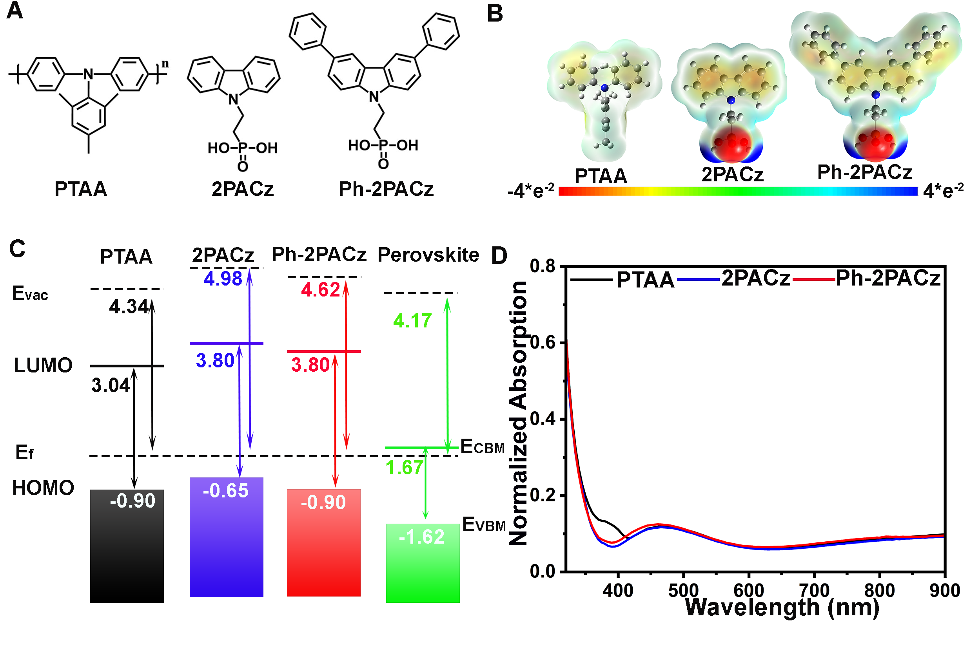
Figure 1. Three different hole selective layers for 1.67 eV p-i-n PSCs.
(A) Chemical structure, (B) electrostatic surface potentials (ESPs), (C) energetic diagrams compared to the perovskite absorber, and (D) normalised absorption of PTAA, 2PACz and Ph-2PACz. Not shown, HOMO levels with respect to E_{vac}, are 5.24eV, 5.63eV, 5.52eV and 5.79 for PTAA, 2PACz, Ph-2PACz and the perovskite absorber, respectively. LUMO levels with respect to E_{vac}, are 2.20eV, 1.83eV, 1.72eV and 4.12 eV for PTAA, 2PACz, Ph-2PACz and the perovskite absorber, respectively. The HOMO levels in (C) are displayed with respect to E_{f} (which must be aligned for current flow during cell operation), suitable for comparing the merits of HSL’s.

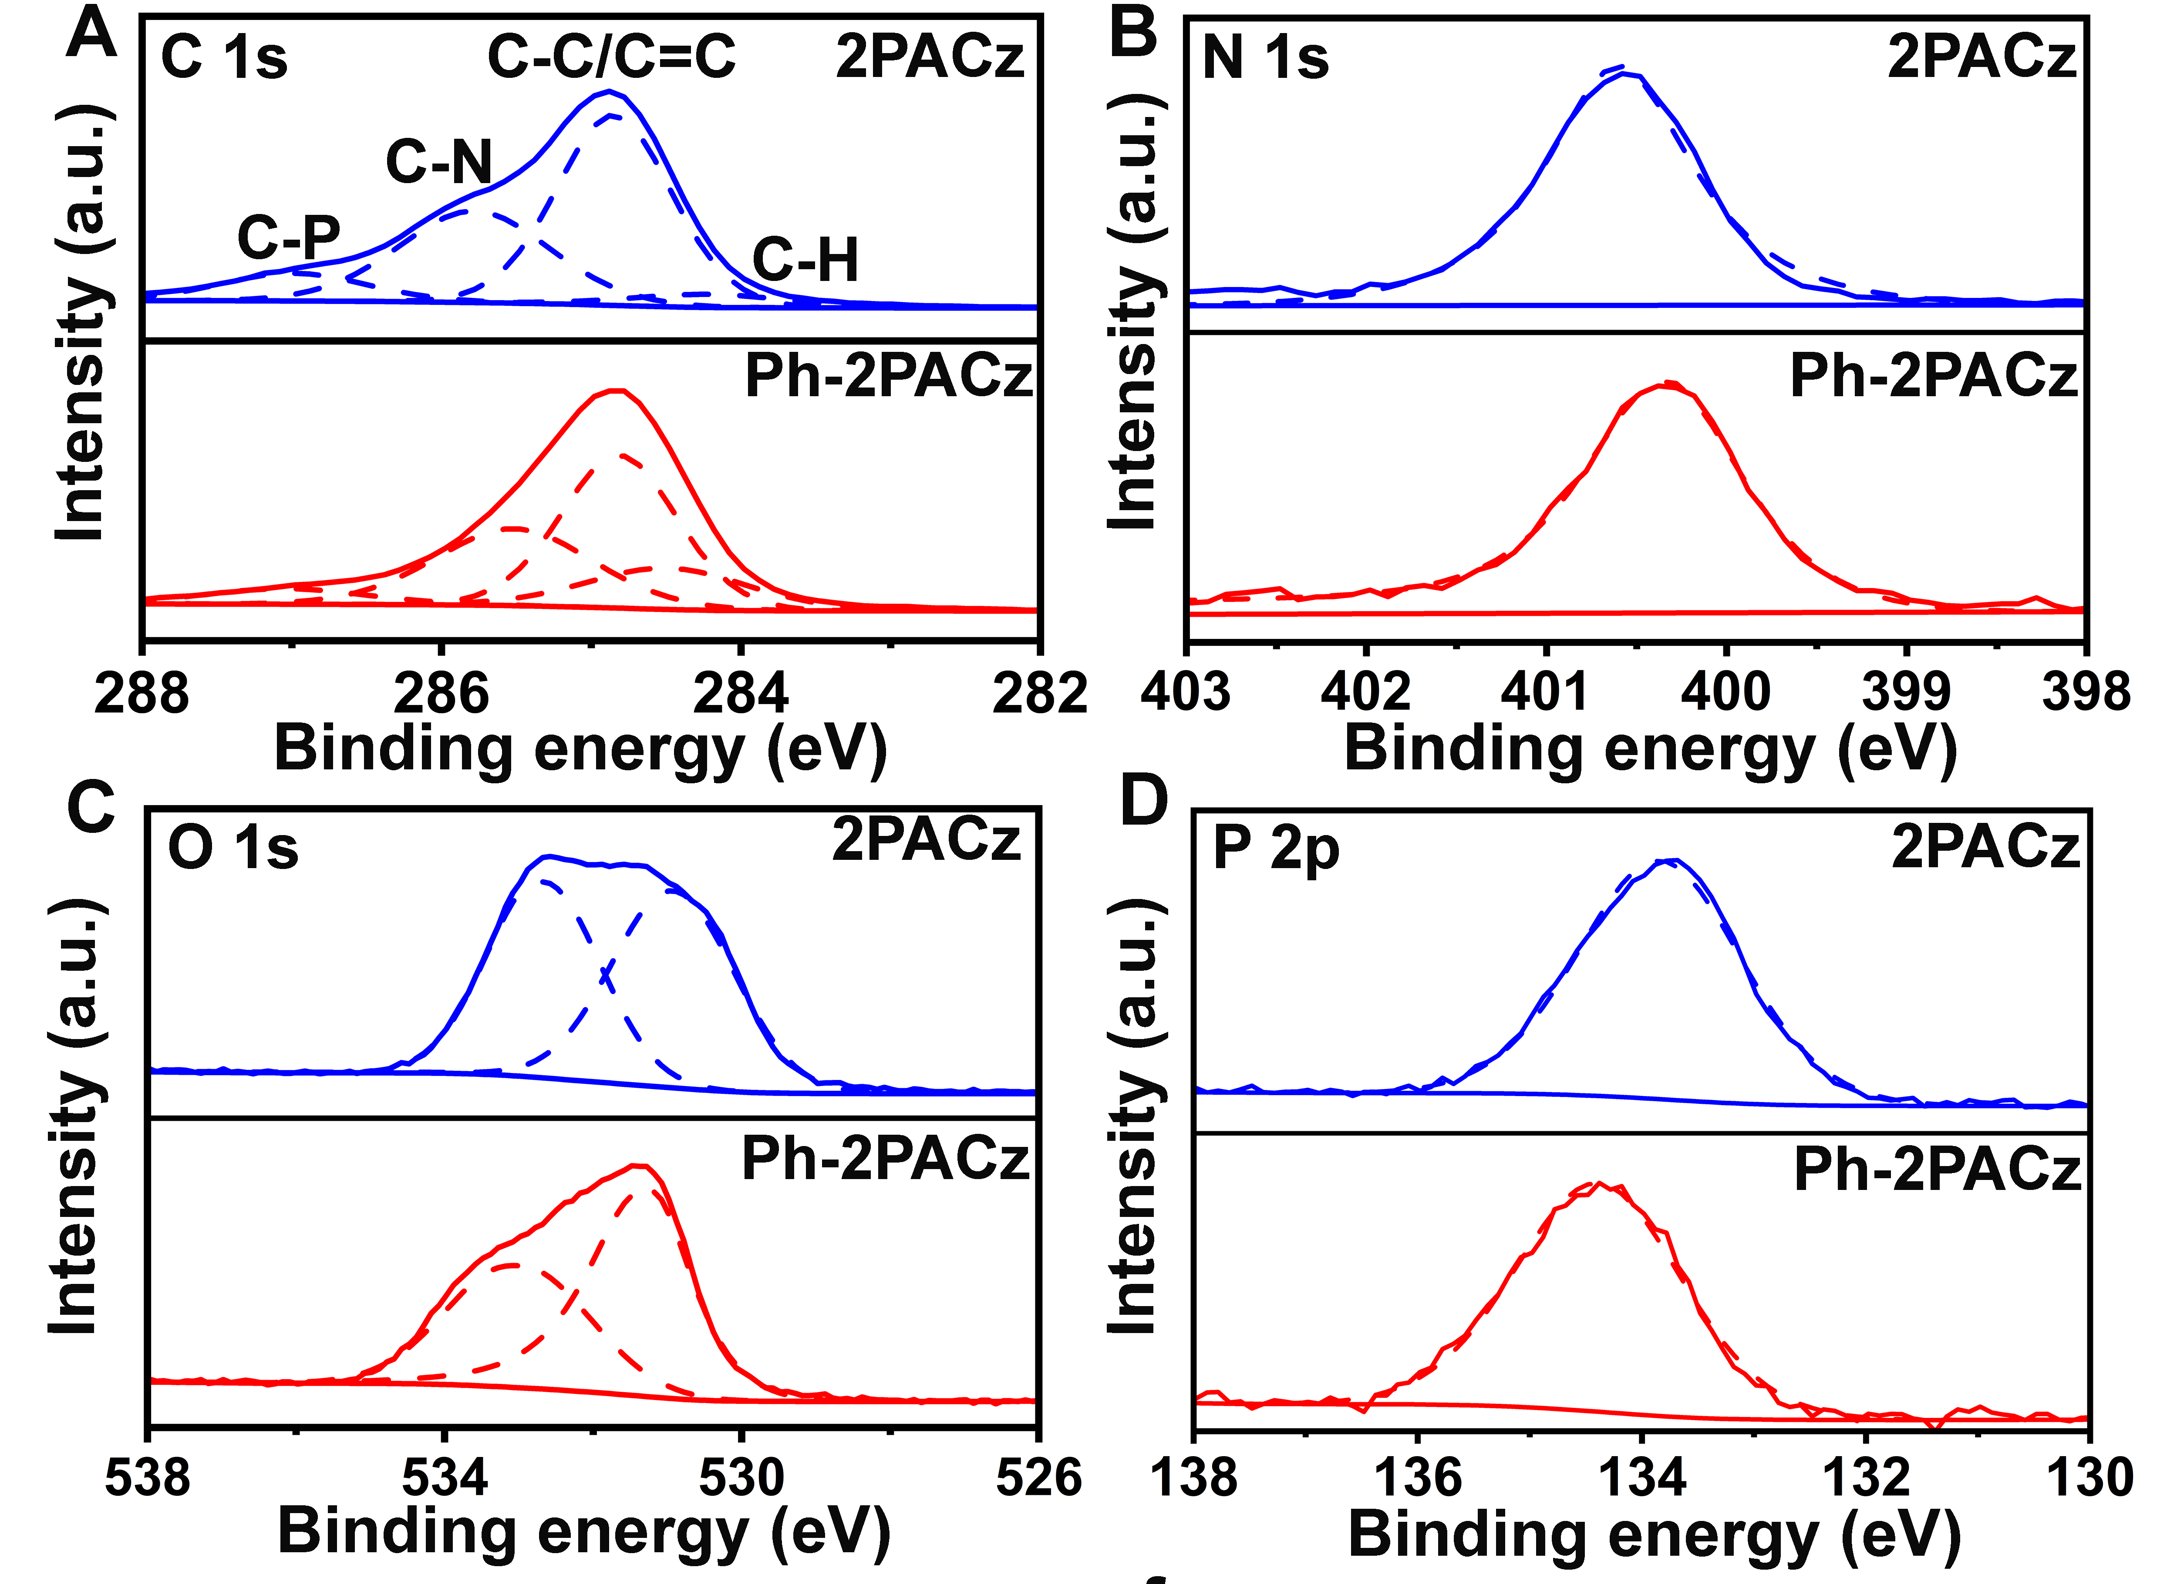
Figure 2. Surface properties of 2PACz and Ph-2PACz.
High resolution X-ray photoelectron spectroscopy (XPS) spectra of (A) C 1s, (B) N 1s, (C) O 1s, (D) P 2p.

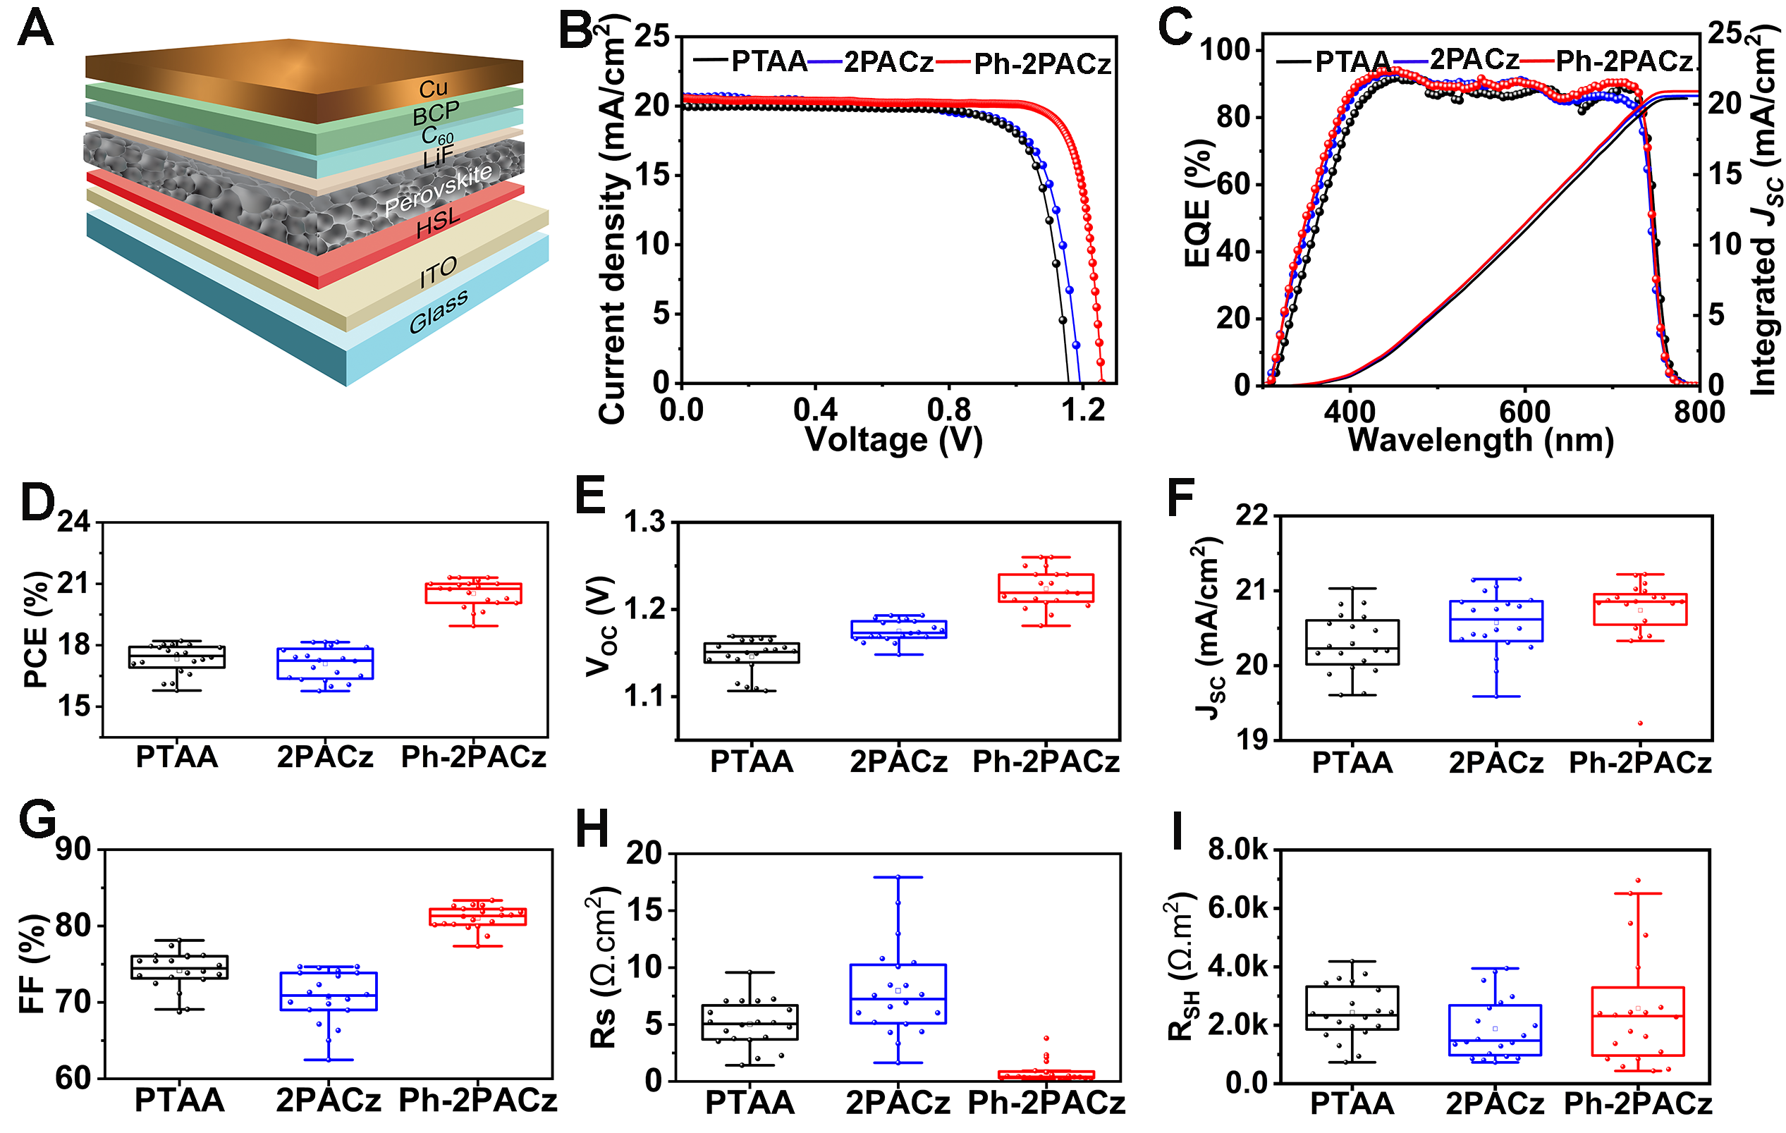

Figure 3. Perovskite solar cell performance.
(A) Schematic of the demonstrated single junction perovskite solar cell.
(B) Light J-V curves of the champion devices using PTAA, 2PACz or Ph-2PACz hole selective layer.
(C) External quantum efficiencies (EQE) and integrated current density curves of typical (non-champion) cells. Their integrated J_{SC}’s are 20.4, 20.6, and 20.9 mA/cm², respectively, showing similar trends to the J_{SC} measured from the light J-V curves.
Distribution of (D) PCE, (E) V_{OC}, (F) J_{SC}, (G) FF, (H) series resistance (R_{S}), (I) shunt resistance (R_{SH}) distributions for multiple devices (20 for each type).

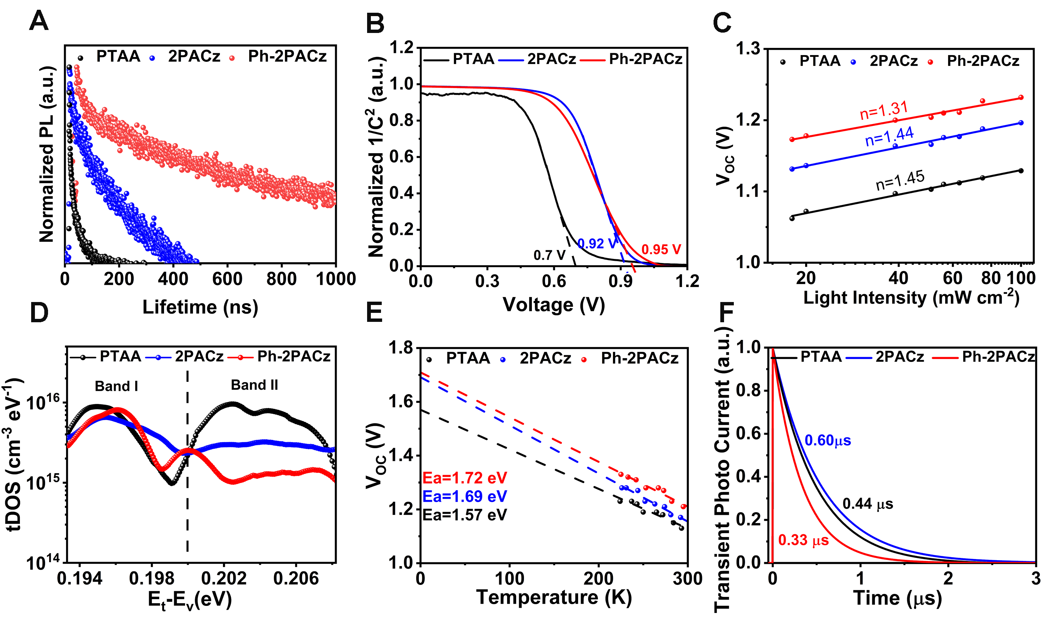

Figure 4. Characterization of perovskite films and solar cells.
(A) Time-resolved photoluminescence (TRPL) spectra of the perovskite film deposited on different HSLs.
(B) Mott-Schottky plot, (C) Light intensity-dependent V_{OC} (for determining the ideality factors (n), (D) thermal admittance spectroscopy (TAS) (for determining densities of defect states (tDOS) at energy levels with respect to their valence bands), (E) temperature-dependent V_{OC} (for determining recombination current activation-energies (E_{a}), and (F) transient photocurrents (TPC) of PSCs using PTAA, 2PACz and Ph-2PACz.

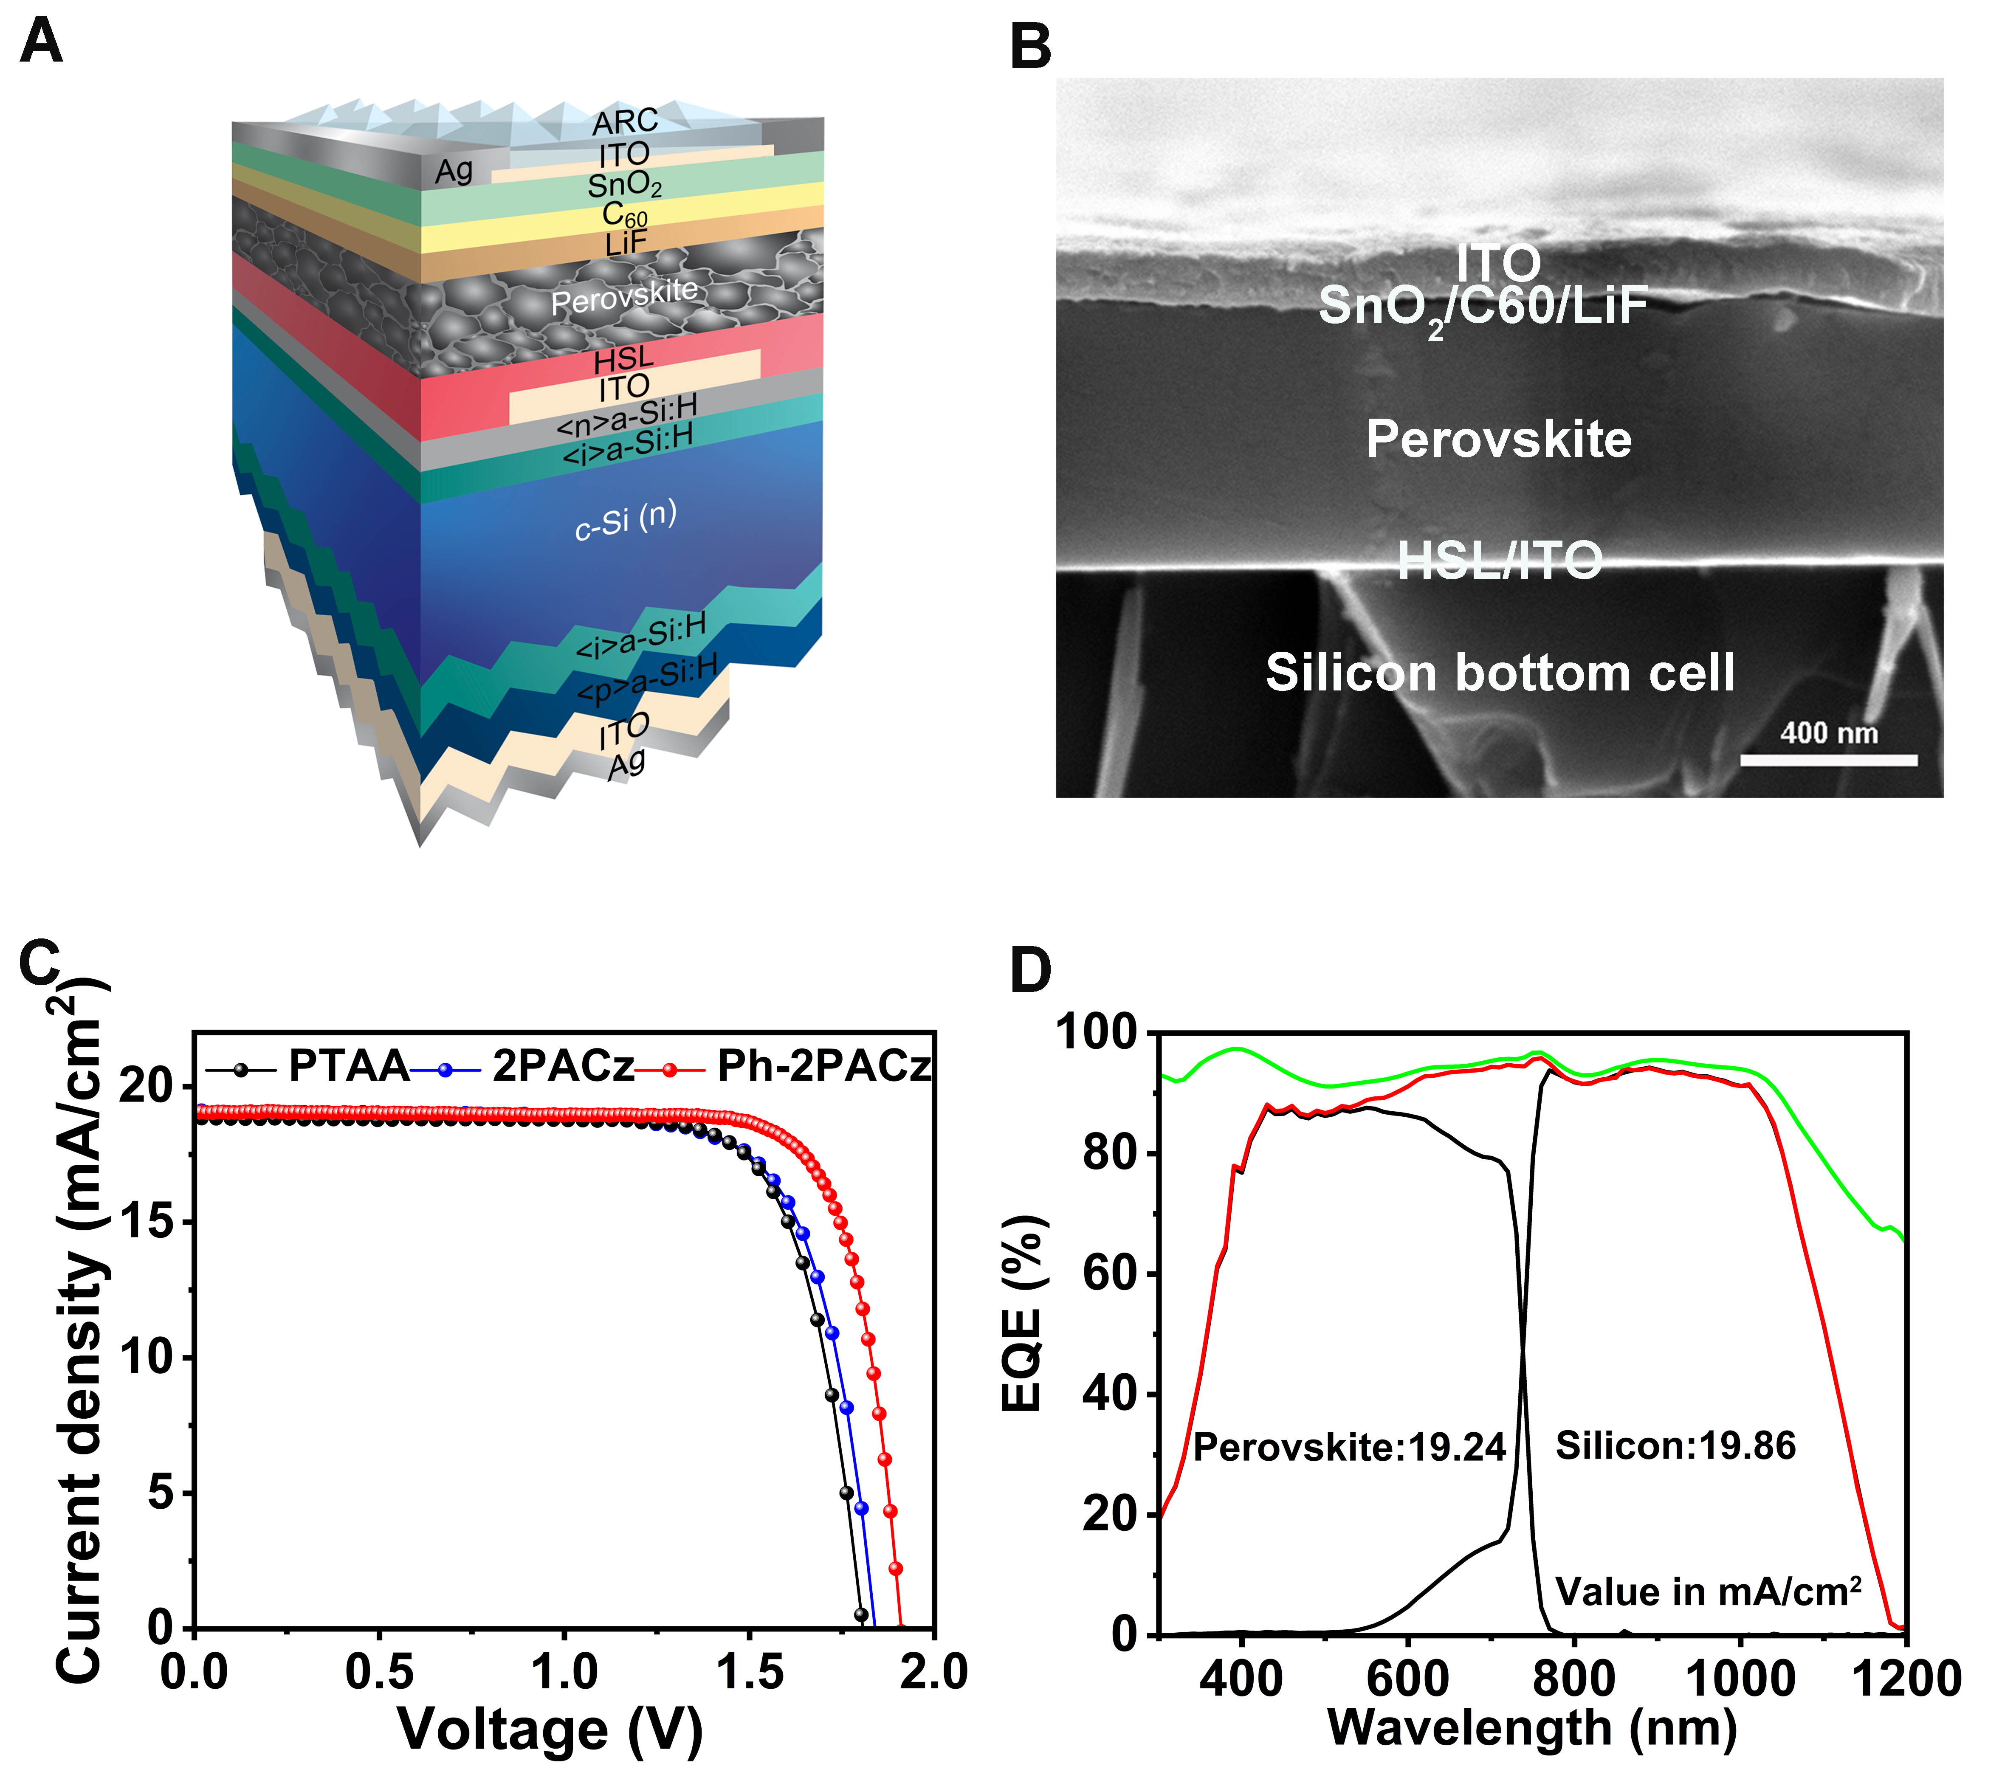

Figure 5. Perovskite silicon tandem cell performance.
(A) Schematic of the p-i-n silicon-perovskite tandem solar cell.
(B) Cross-sectional scanning electron microscopy (SEM) images of the tandem cell with Ph-2PACz HSL.
(C) J-V curve of the champion tandems using different HSLs.
(D) External quantum efficiency (EQE) curve and reflection of the champion tandem solar cell using Ph-2PACz.
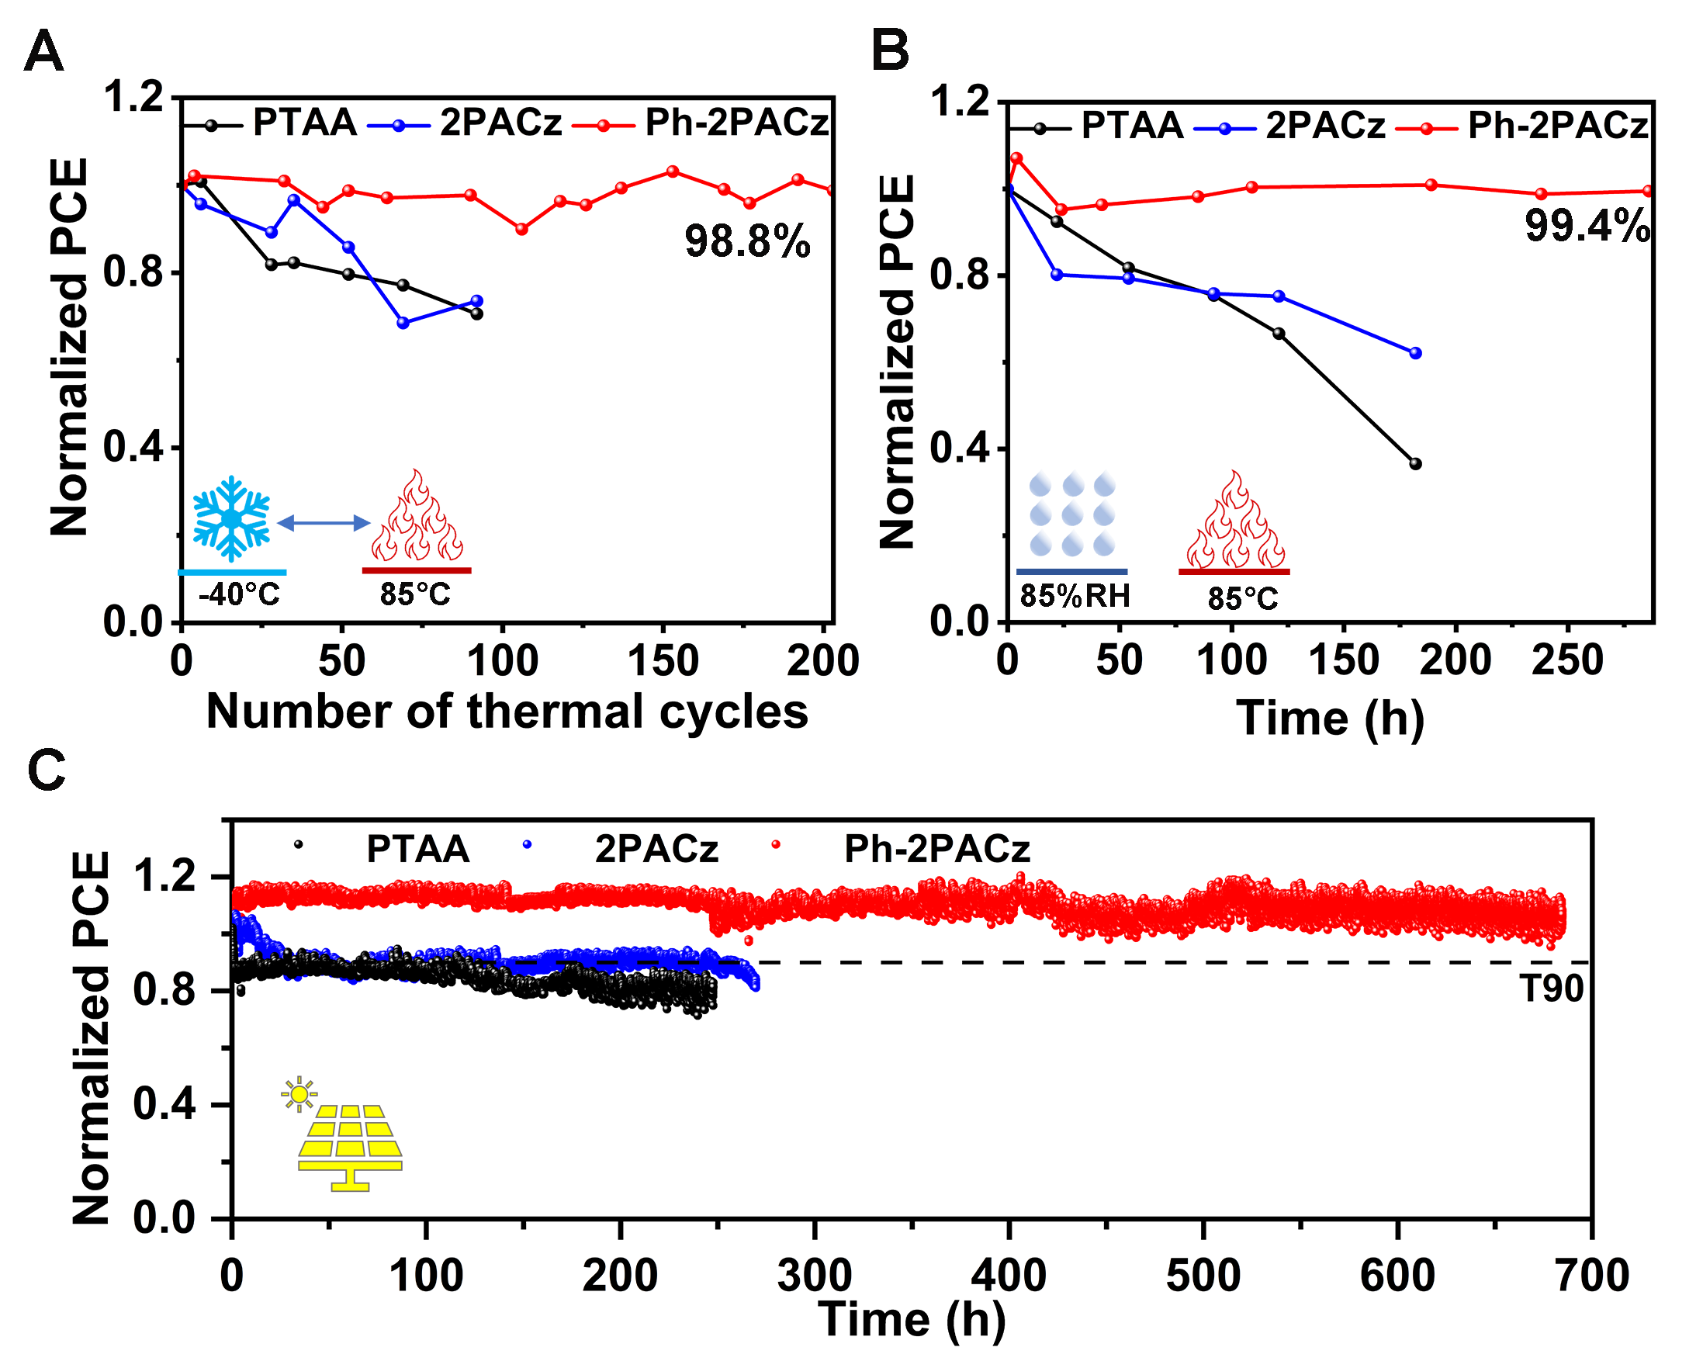
Figure 6. Stability of encapsulated tandem devices.
PCE evolution under (A) thermal cycling (between -40℃~85℃), (B) damp-heat (85℃, 85% RH) tests, and (C) maximum power point tracking.

Table 1. Photovoltaic parameters of champion single junction PSCs based on three different HSLs
HSL | V_{OC} (V) | Jsc (mA/cm²) | FF (%) | PCE (%)
PTAA | 1.16 | 19.9 | 78.1 | 18.0
2PACz | 1.19 | 20.7 | 74.1 | 18.3
Ph-2PACz | 1.26 | 20.5 | 82.6 | 21.3

Table 2. Photovoltaic parameters of champion perovskite-silicon tandem devices based on three different HSLs
 | V_{OC} (V) | J_{SC} (mA/cm²) | FF (%) | PCE (%)
PTAA | 1.81 | 18.8 | 76.3 | 26.0
2PACz | 1.84 | 19.1 | 74.6 | 26.2
Ph-2PACz | 1.91 | 19.1 | 79.1 | 28.9

